Conestoga College
Course | INF08965 - Network and Security
Activity Title | Internet Traffic Analysis
Student Name | Twinkle Akhilesh Mishra
Student Number | 8894858
Lab performed on (Date): | 27-Jan-2025

Objectives
- Analyse network traffic using traffic capture utility like Wireshark.
- Setup an FTP server in a Virtual Machine
- For IP addressing in this lab, XY (58) represents the last two digits of your student ID.

Step 1: Install and launch the FTP server.
- Configure Host-Only Adapter:
  - Using VirtualBox, created a Host-Only Ethernet Adapter.
  - Given the IP address 192.168.58.1 and the network mask 255.255.255.0.
  - Setup DHCP server with IP address 192.168.58.100
  - Lower/upper bounds: 192.168.58.101 - 192.168.58.254
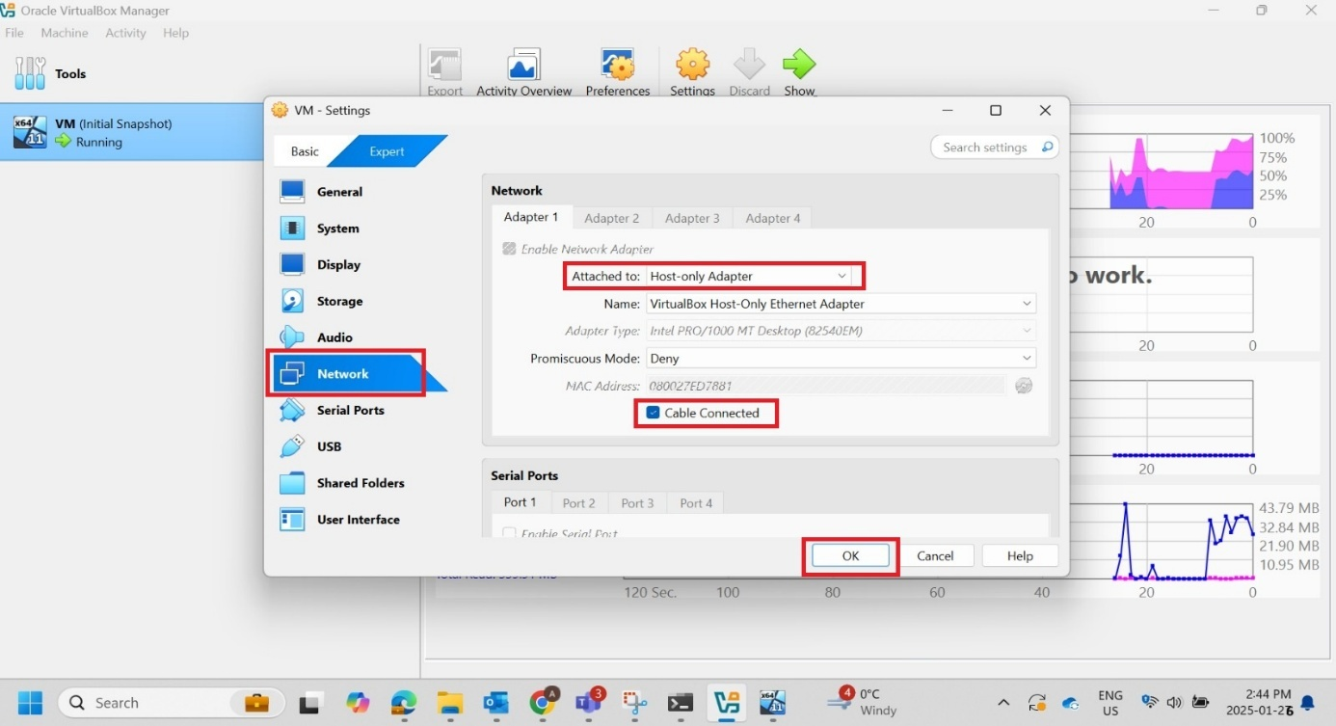

- Change Adapter IP to .58:
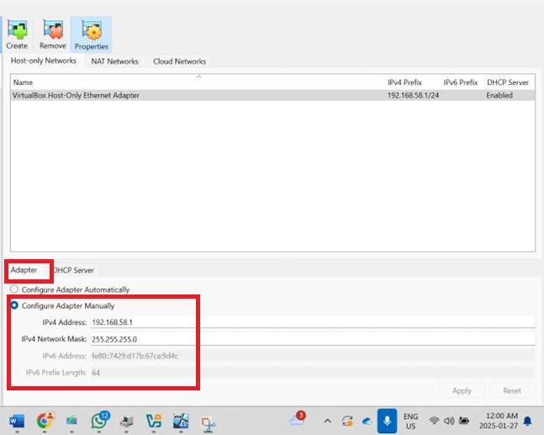

- Set up DHCP Server to .58
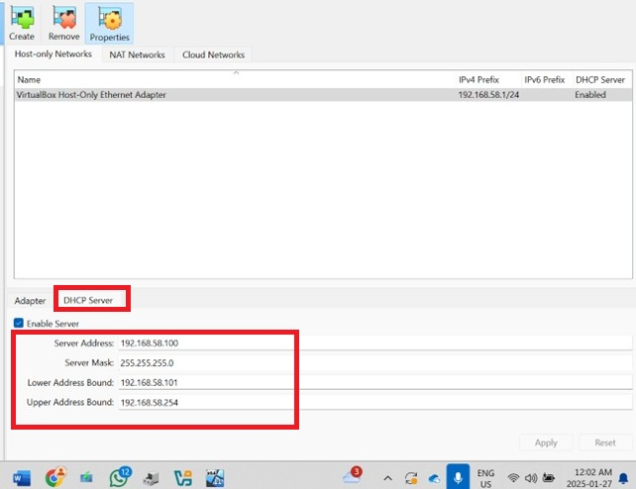

- Take a Snapshot:
- Created an initial snapshot of the Windows 10 VM for backup.
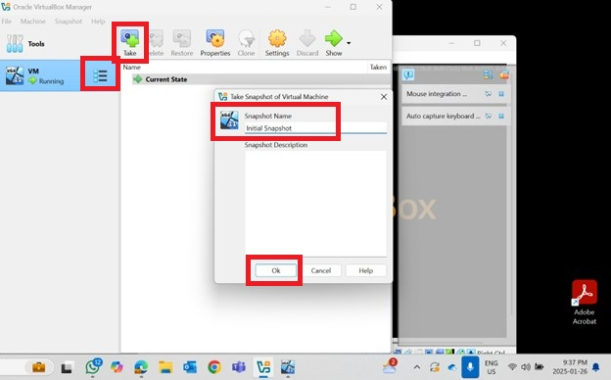
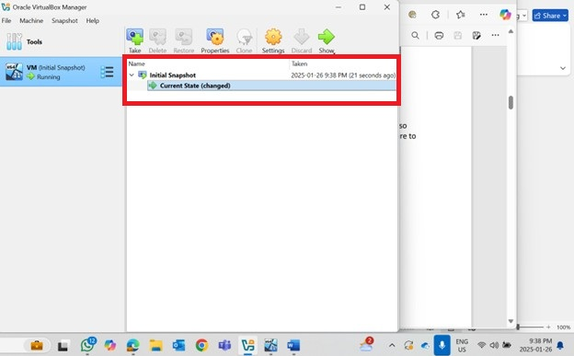

- Install Cerberus FTP Server:
  - Installed Cerberus on the VM with default settings.
  - Allowed unencrypted FTP traffic and disabled SSL/TLS.
  - Set up the Anonymous user with a password.
  - Verified the FTP server IP address.

- Create and Test File:
  - Created a text file named after Cerberus in C:\ftproot.
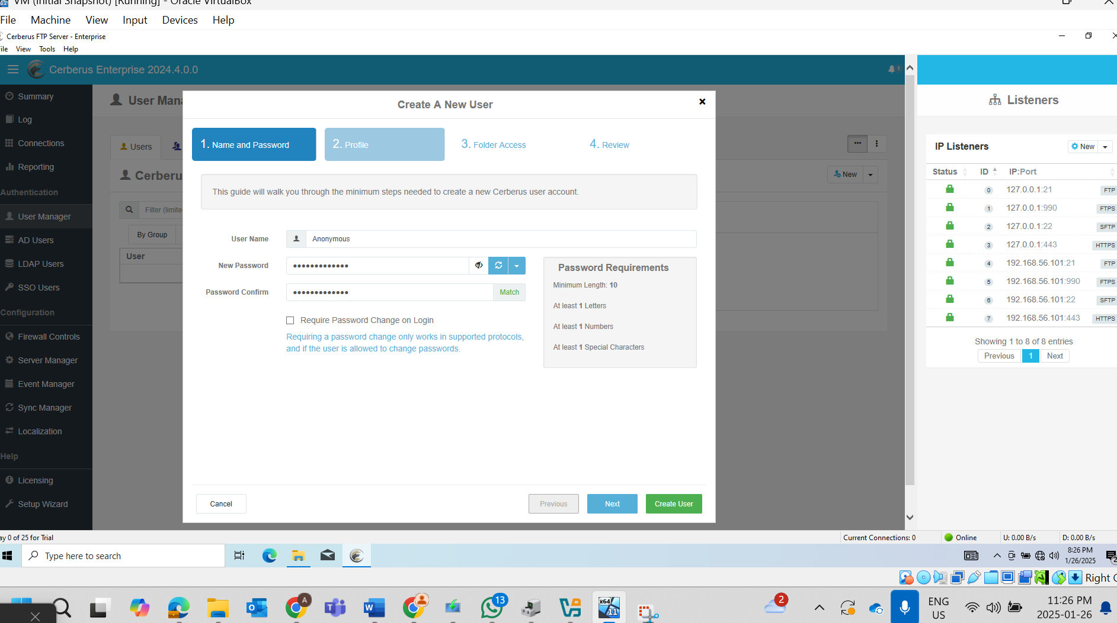
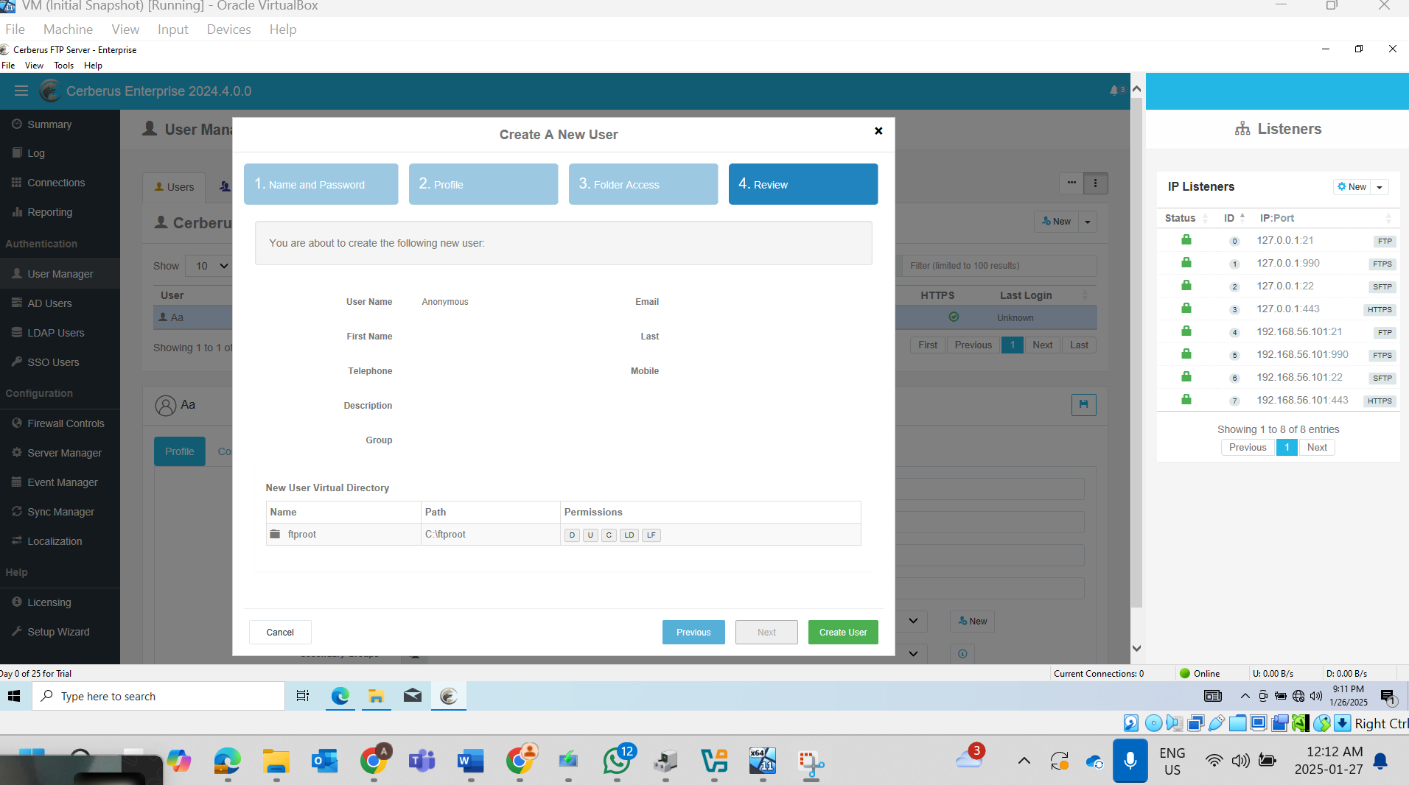
- Checked the box for FTP to not allow unsecured FTP server connections
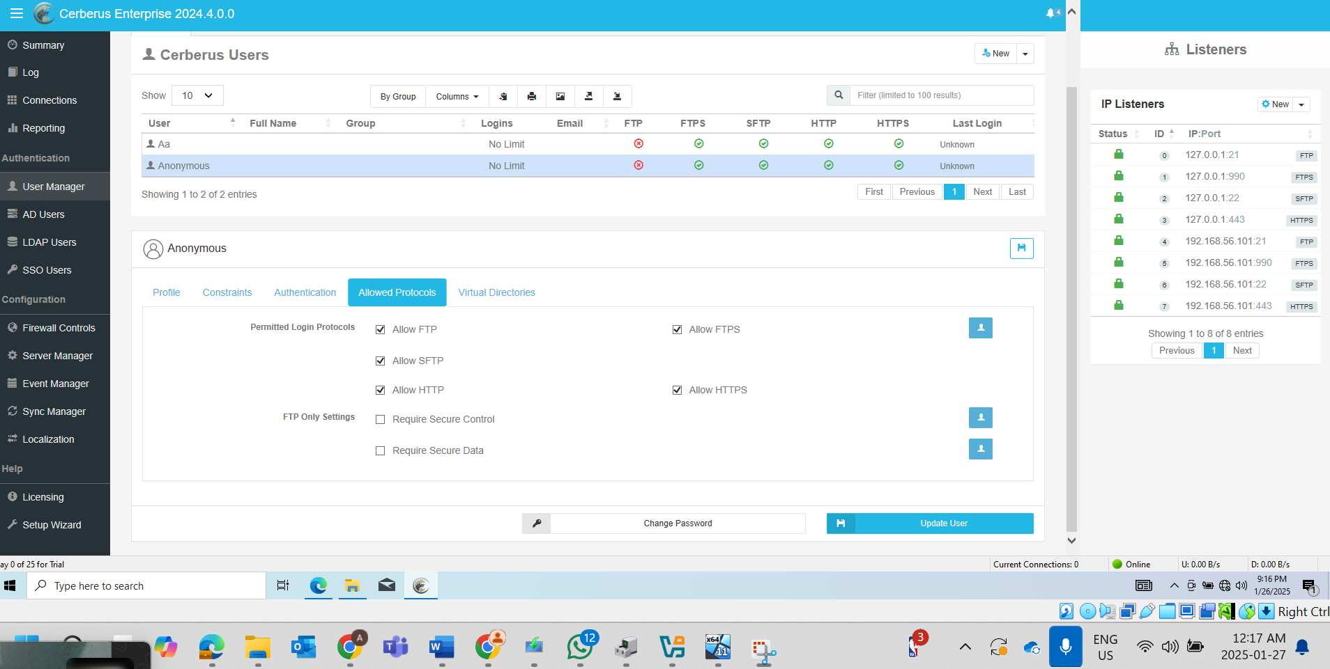

- Disable secure control and data
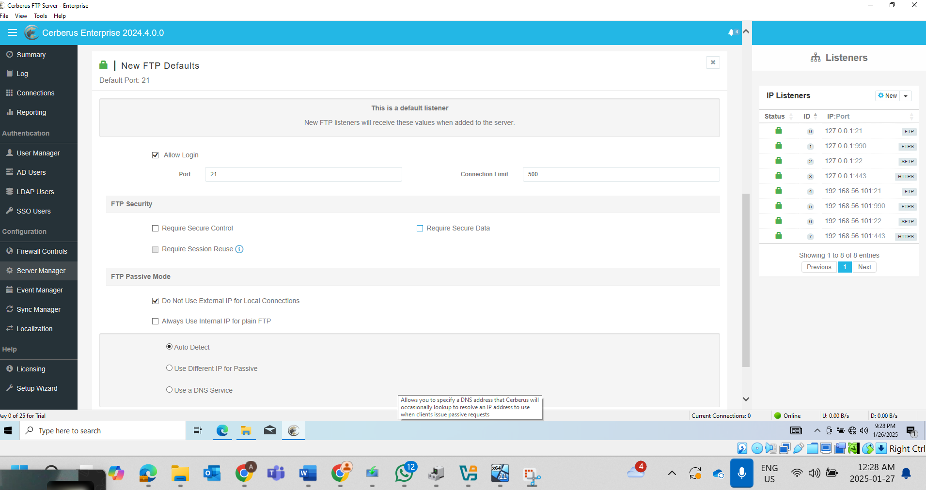

- Disable SSL/TLS
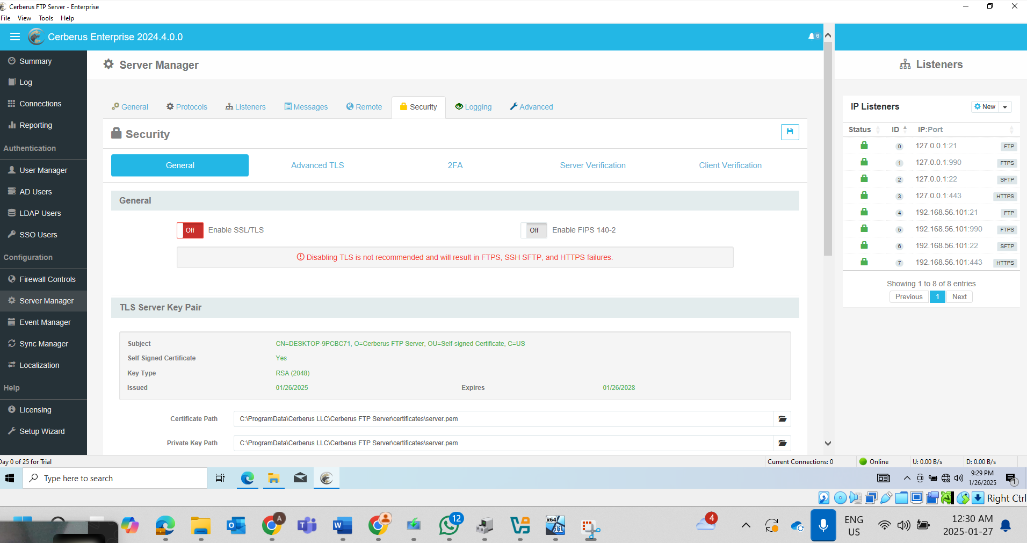
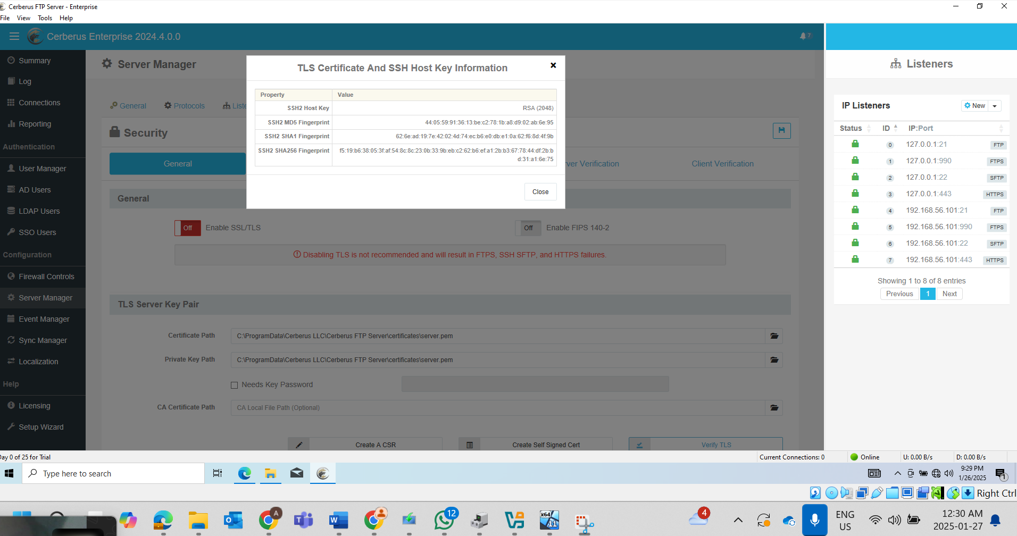

- Setting password for Anonymous user:
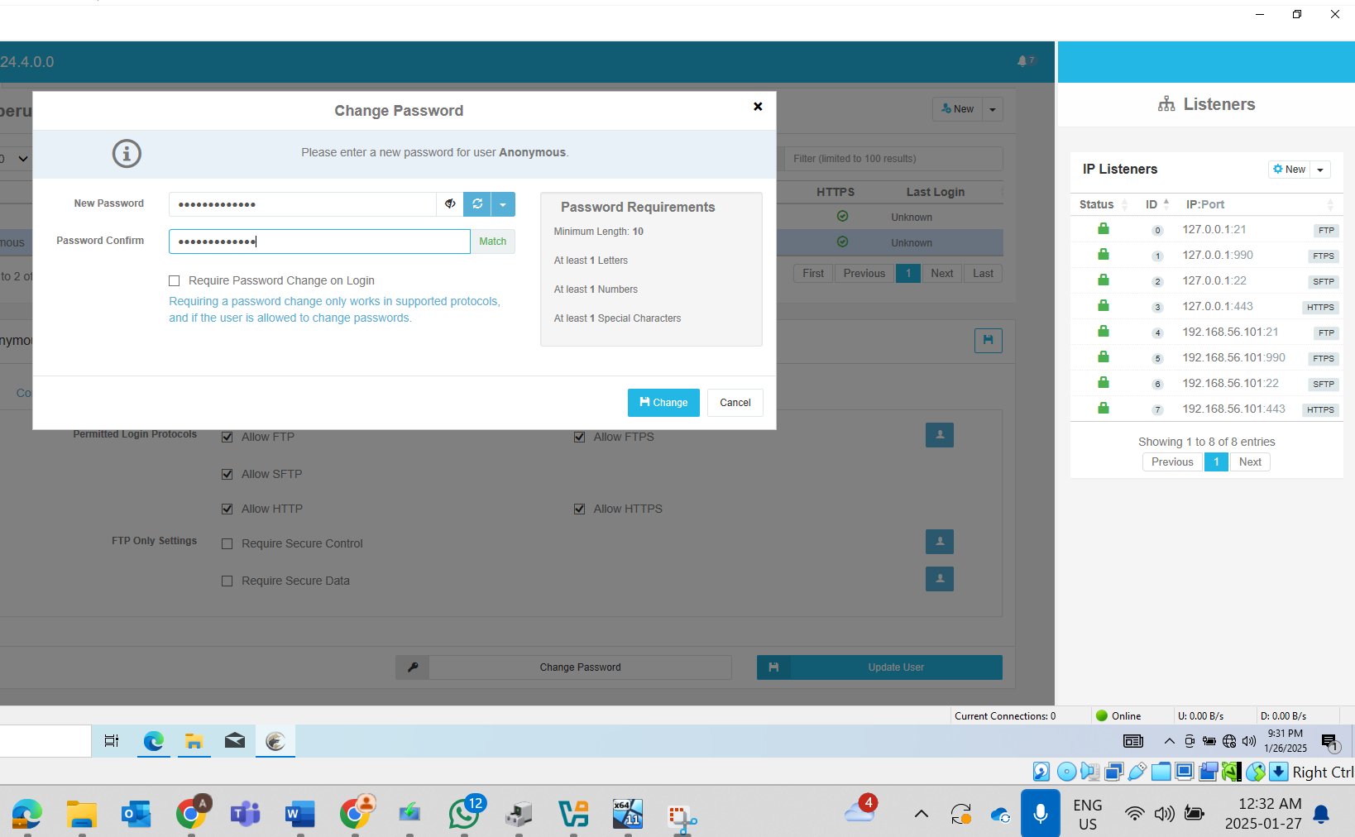

- IP address for Cerberus FTP Server:
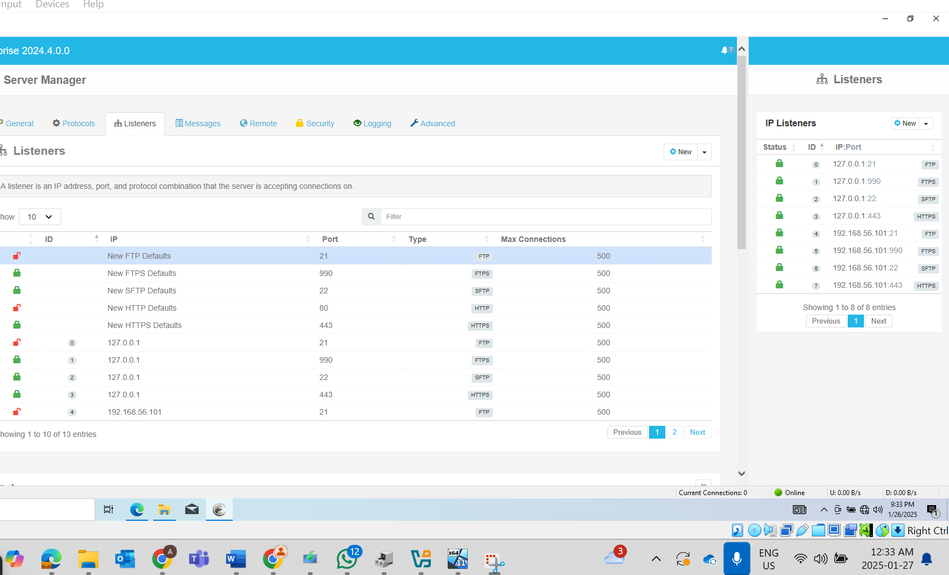

Step 2: Download File and Capture FTP Traffic
- Install FileZilla Client:
  - Installed FileZilla Client on the host machine.
- Capture FTP Traffic with Wireshark:
  - Started Wireshark on the host and captured traffic on the Host-Only Network.
  - Used FileZilla to connect to the FTP server, login, and download the test file.
  - Verified server logs in Cerberus.
- Downloading file hosted on the FTP Server using FileZilla:
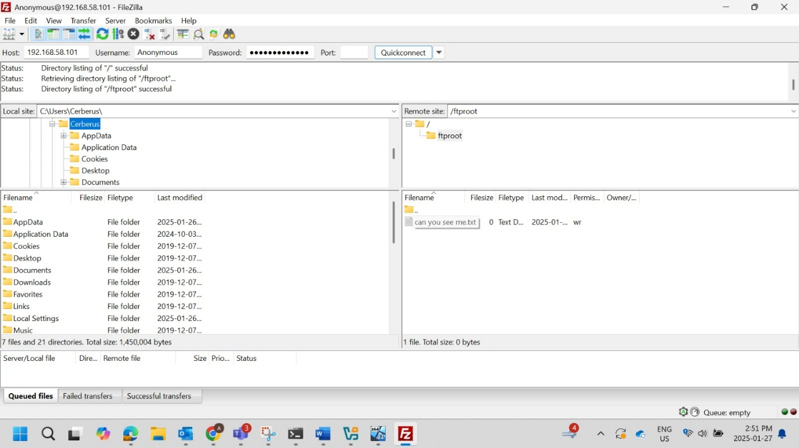

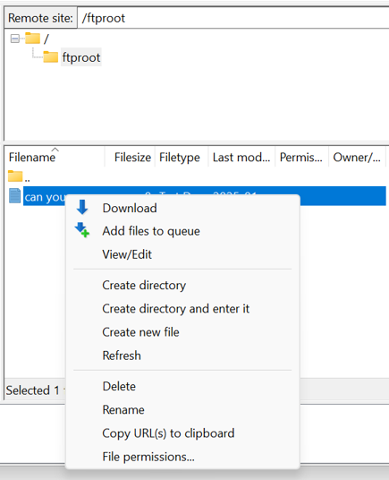

- Analyze Wireshark Data:

- Applied tcp.port == 21 or tcp.port == 20 to display FTP traffic.

- Captured clear-text username and password during login.

- Verified successful 3-way handshakes (SYN, SYN-ACK, ACK).

- Observed file transfer in plain text in captured packets.

- Visualized communication and handshakes between client and server.

Output #1: Apply filter to view only FTP related traffic
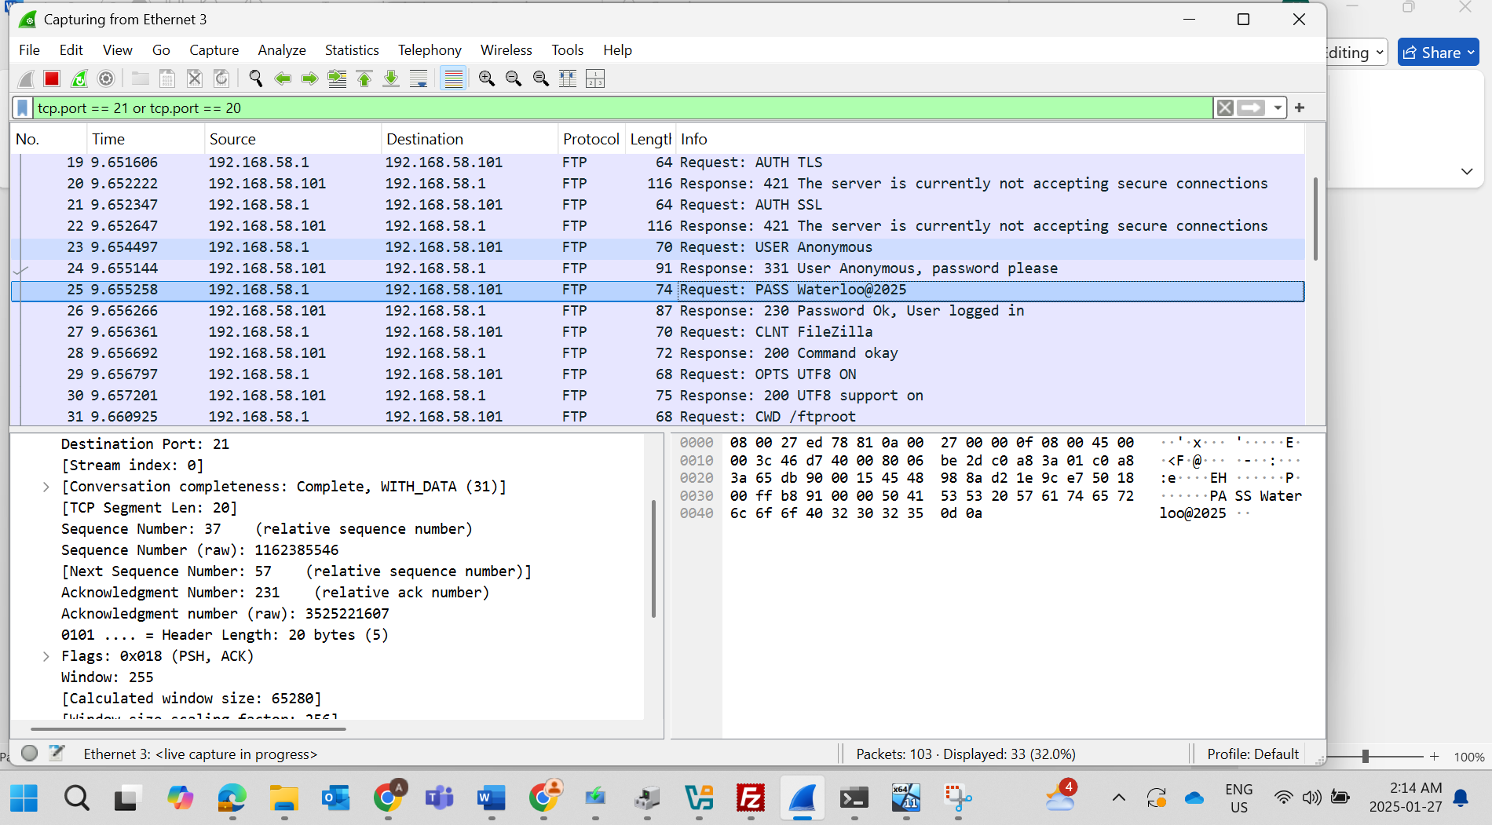

Output #2: Flow graph in Wireshark
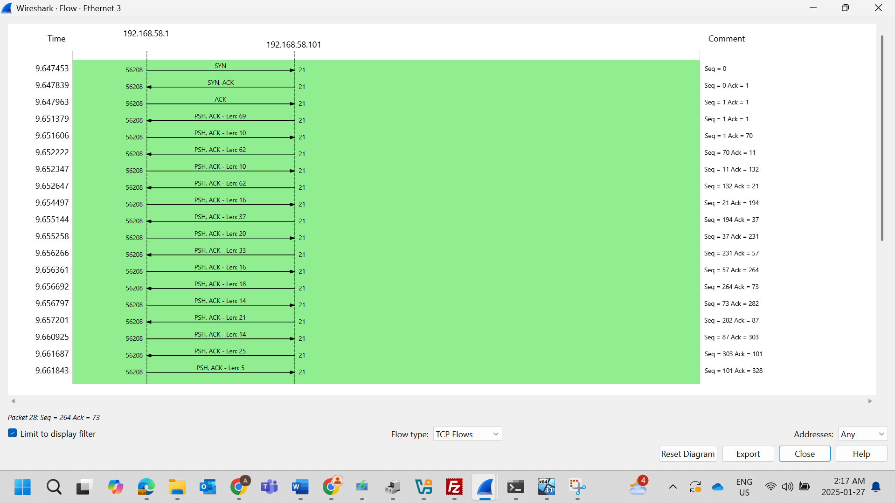

Output#3: Wireshark Capture of File Transfer in Clear Text
